Customer Behavior Prediction

Team Members:

Haoming Wang

Xuetian Xie

Shuo Yu

Shuoxin Yu

*Original Work Statement*

We the undersigned certify that the actual composition of this proposal was done by us and is original work.

|  | Typed Name | Signature |
| --- | --- | --- |
| Haoming Wang | Haoming Wang |  |
| Xuetian Xie | Xuetian Xie |  |
| Shuo Yu | Shuo Yu |  |
| Shuoxin Yu | Shuoxin Yu |  |

1. ***Executive Summary***

In today's fiercely competitive business landscape, understanding customers' individual preferences and buying behaviors is paramount. Personalized customer experiences are no longer a luxury but a necessity, and a key differentiator for businesses. Our Customer Personality Analysis project, therefore, is a strategic initiative aimed at harnessing customer data to personalize services, enhance customer satisfaction, and ultimately, drive growth.

We procured a rich dataset from Kaggle, comprising over 2000 customer records, with detailed attributes such as age, income, number of children, purchasing habits, response to promotions, and preferred order placement channels. Our initial analysis involved an exploratory data analysis (EDA) and data cleaning, ensuring our study's foundational integrity. The EDA allowed us to uncover significant trends, most notably, the dominance of wine purchases in the last two years, leading us to focus primarily on this category.

The next phase of our project involved Recency-Frequency-Monetary (RFM) segmentation based on the customer data. This widely recognized marketing technique allowed us to categorize customers based on their purchase history, identifying the recency, frequency, and monetary value of purchases. This understanding of customer behavior, particularly regarding wine purchases, was instrumental in our subsequent steps.

Following RFM segmentation, we built several predictive models, including regression trees, naive Bayes, logistic regression, and random forest algorithms. Each model offered unique insights and was evaluated based on performance and suitability for various purposes. This multi-model approach provided us with a comprehensive view of customer behaviors and allowed us to predict future buying patterns accurately.

Our next step was to construct association rules, which helped us delve deeper into customer personality analysis. These rules served to identify patterns and connections between different customer attributes, enabling us to determine the personalized service to offer new customers.

In conclusion, the Customer Personality Analysis project underscores the importance of a deep, nuanced understanding of our customers in an intensely competitive market. By leveraging cutting-edge data analysis techniques, we can tailor our services to meet individual customer needs better, thereby increasing loyalty and driving sales. We remain committed to enhancing our analytical capabilities and incorporating more sophisticated technologies and information to continually refine our understanding of customer personalities. This continuous improvement is key to remaining competitive and delivering superior customer experiences.

1. ***Data Description***
   1. **Data Source**: [BUDT758T_TeamS_Data_Source](https://www.kaggle.com/datasets/imakash3011/customer-personality-analysis?datasetId=1546318&sortBy=commentCount&searchQuery=rfm)
   2. **Number of Variables (k)**: 29
   3. **Sample Size (n)**: 2240
   4. **Data Dictionary(Full see appendix)**:

| Column Name | Type | Unit | Column Description |
| --- | --- | --- | --- |
| ID | int | NaN | Customer's unique identifier |
| Year_Birth | int | NaN | Customer's birth year |
| Education | chr | NaN | Customer's education level |

* 1. Samples:



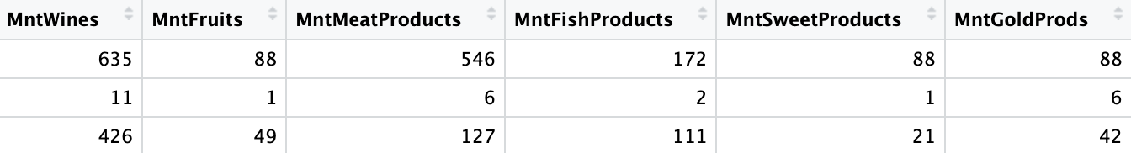

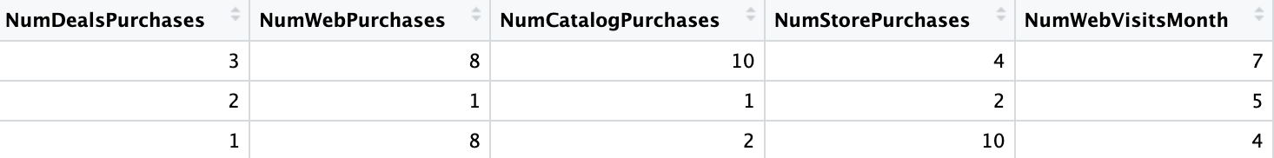



* 1. **Interest**:

The dataset encompasses various facets for detailed scrutiny. It incorporates characteristics about the customer, such as age, income, and education. Additionally, it includes information on the customer's consumption patterns, such as expenditure across different categories, preferred locations for placing orders, and their inclination towards promotional offers. Leveraging this data can enable us to deliver a more insightful and accurate interpretation of customer behavior analysis.

* 1. **EDA**:

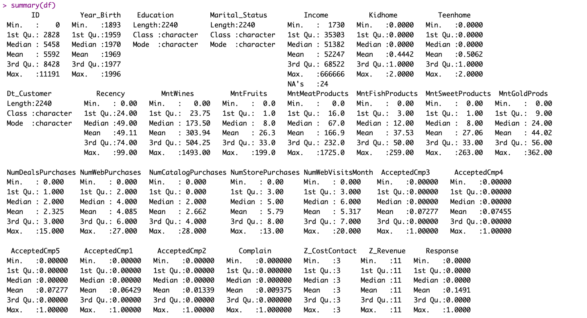

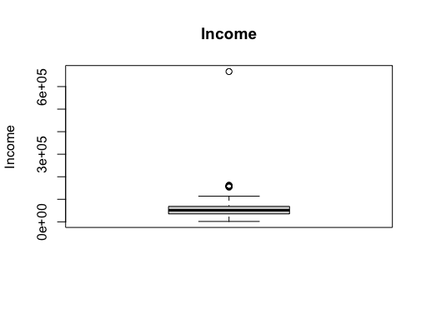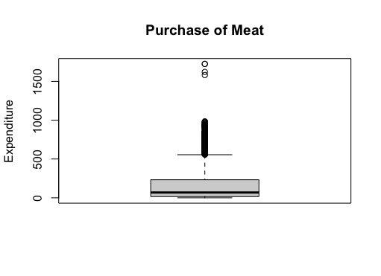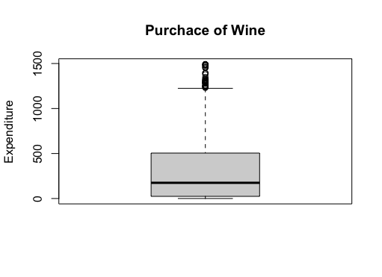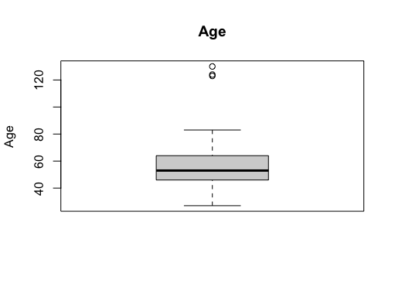

* 1. **Data cleaning and preprocessing**:
     1. Dropping Na’s (24 rows)
     2. Column transformation: Year_born -> Age
     3. Dropping outliers:
        + Upper limit: 85% quartile + 1.5*IQR;
        + Lower limit: 15% quartile - 1.5*IQR
     4. Dropping duplicated columns: Z_CostContact, Z_Revenue
     5. Supervised Learning Models:
        + Max_Spent: Wine, Meat, Gold, Fish, Sweet
          1. We have computed a max amount spent based on these numerical columns ('MntFruits','MntWines', 'MntMeatProducts', 'MntFishProducts', 'MntSweetProducts', 'MntGoldProds'), and label the customer max_spent accordingly. For example, if customers spend the most on wine, we will label the max_spent as Wine.
        + Wine: 0,1
          1. Because we mainly focus on the amount purchase of wine, so we created a label for whether the customer spend the most money on wine
        + For columns: "Wine", "max_spent", "Education", "Marital_Status", "AcceptedCmp3", "AcceptedCmp4","AcceptedCmp5","AcceptedCmp1", "AcceptedCmp2", "Complain","Response", we transform them to catagorical data;
        + For columns: “Income”, “Kidhome”, “Teenhome”, “Recency”, “NumDealsPurchase”, “NumWebPurchase”, “NumCatalogPurchase”, “NumStorePurchase”, “NumWebVisitsMonth”, “Age”, we keep them as numeric data.
     6. Association Rule Model

Since association rules only accept factor or categorical variables, we had preprocessed our initial dataset in order to perform the analysis.

* + - * Income, Age

Since income and age are both numerical, therefore we have to factor them into three levels based on the 25%, and 75% quartile of the overall dataset. For example, for customer whose income is in the lower quartier will have a label as ‘low’.

# Kidhome, Teenhome, Complain, Response

For numerical columns including Kidhome, Teenhome, Complain, and Response, we convert them into binary variable. For example, if Kidhome = 0, we labeled it as “No”, if Kidhome is greater than 0, we labeled them as “Yes”. Do the same thing for the Teenhome and Complain. For the Response variable, we renamed the column name to “last_campaign”.

* + - * Max_Spent: Wine, Meat, Gold, Fish, Sweet

We have computed a max amount spent based on these numerical columns ('MntFruits','MntWines', 'MntMeatProducts', 'MntFishProducts', 'MntSweetProducts', 'MntGoldProds'), and label the customer max_spent accordingly. For example, if customers spend the most on wine, we will label the max_spent as Wine.

* + - * purchase_mdeia: Web, Catalog, Store

We have computed a max number of purchase through all the media these numerical columns ('Num Purchases', 'NumCatalogPurchases', 'NumStorePurchases'), and label the customer purchase_mdeia accordingly.

* + - * deal: prefer,not prefer / webvisit: more-likely,less-likely

We have labeled deals and webvisit based on whether their number is higher than the median of the overall datasets, and assign labels accordingly.

* + - * accept_campaign: yes,no  
        If the customer accepts any of the five campaigns then yes, other no.

1. ***Research Questions***

From a small neighborhood convenience store to a famous top multinational retail corporation that operates a chain of hypermarkets, they all share one thing in common which is a group of satisfied, happy customers. Without a steady customer flow, no business can survive. And this is why what we do is important – Customer Analysis.

# We provide our clients(from groceries stores to big name operations) with detailed customer analysis results. Not just presenting them with a bunch of raw numbers or random model outputs, instead we help them understand how these numbers would help them to improve their business performance and how to apply them in the real world in solid steps. Other than that, we also provide our clients with detailed promotional strategies and future marketing policies that they would act right now to increase their KPI and ROI.

# Speaking of improving KPI and ROI, which is a big blueprint for every business, but how can we really help? And what is our starting point? We will take three main steps into place, they are existing customer analysis, future customer behavior prediction, and potential marketing strategies.

# The first question is among all the customers that we have had, who are our most important customers? Who would be our returning customers? Which group of customers are at risk of losing them? After we have sorted them out, what solutions can we develop to save those at risk and maintain our loyal customers?

In order to help our clients to improve their business performance, analyzing existing customers is not enough, identifying future customers' behavior is also important because they would likely bring us future profit.

Therefore, we need to know what our current customers could tell us about them. After a little bit processing of the customer data, we have found out that a large portion of our customers are more likely to spend the max amount on the wine products among all of their purchases. Since wine would bring us the max revenue in this dataset, thus, we decide to predict for each customer whether they will spend the max on wine?

However, we would like to do more than just predicting our customer’s decision on spending max on wine or not, we also want to know what factors of the customers behaviors, background, characteris, any information that we could gather would affect their decision of spending max wine? Among those, what are our most useful customer factors in this prediction?

In reality, do customers always stay the same? The answer is no. For example, some customers might suddenly decide to be a vegan, therefore the amount that they spend on meat will decrease. How would this change affect their decision on spending the max on wine? There are customers who like to use deals, and coupons, and there customers who do not like discounted products. Does this kind of change change their choices on spending the max on wine?

What are our next steps after predicting potential customers who are more likely to purchase wine? What are the actionable advice that we could provide right now that can help our clients directly on next month marketing? How do we identify customer segments?

After accomplishing and finding the answers to the above questions, we have successfully developed a business model on the customer analysis that could actually help clients to act right now to improve their business performance in every aspect.

1. ***Methodology***
   1. **Recency-Frequency-Monetary Model**

To gain a succinct understanding of our customers, we've chosen to employ the Recency-Frequency-Monetary (RFM) model as a quantification technique to better comprehend customer behavior. Our initial step involves constructing an RFM matrix, factoring in the customer's recency, total orders in correlation to their membership duration (frequency), and the overall expenditure (monetary value). Subsequently, we transform Recency, Frequency, and Monetary metrics into scores ranging from 1 to 5, utilizing rank and cut. These scores are then recorded as recency_score, frequency_score, and monetary_score. We further streamline this by combining recency_score and frequency_score into a singular variable, which we denote as RF_SCORE. Finally, to enhance our understanding of customer distribution, we leverage the RF analysis to generate pie charts for a more visually intuitive representation.

* 1. **Model Selection and Performance Measures**

In order to better understand our customers, an appropriate and accurate model is required to determine strategies for target customers. To predict whether a customer will spend the most on wine, we used four supervised methods in machine learning, including regression tree, random forest, and logistic regression, so we can use the labeled datasets to train models to predict outcomes. Before generating the model, we split the dataset into 60% of training data and 40% of test data. After using the training data to train the model, we used a confusion matrix to calculate the accuracy score and the ROC curve to compare the performance of these models.

* 1. **Supervised Models**

The regression tree can quickly reveal the relationship in the data and provide a human-readable tree, with information about what variables are used and how variables are used to predict the outcome. It is easy to understand and useful to present to our client. We also pruned our original tree to remove parts of the tree that do not provide powerful predictions. Random forest is similar to a regression tree, but it contains several decision trees to produce a predictive model. It is a good option to predict the outcome more accurately. Logistic regression estimates the probability that a customer will spend the most on wine. We used a cut-off of 0.5 to determine whether a customer spends the most on wine. If the probability of a customer spending the most on wine is greater than 0.5, we classify the outcome as 1, otherwise, the outcome is 0. We begin with a logistic regression of all variables and use backward feature selection to choose the most relevant variables. With the help of step() function, the model is more interpretable and the chance of overfitting is reduced. The naive Bayes model provides the conditional probability of a customer will spend the most on wine, based on a given class or category. The output is easy to interpret and easy for our client to understand.

* 1. **Unsupervised Model: Association Rules**

We also discovered some interesting relationships between variables by using association rules, which is one of the unsupervised machine learning techniques that would also provide helpful insights. However, we have to convert the dataset into item matrix format. We first convert all numerical columns to categorical columns. For some numerical columns such as Age and Income, we use ifelse() function to determine the age level and income level, so they can be categorical columns. The transaction() function automatically creates the item matrix to be used in the association rule.

1. ***Results and Finidings***
   1. **Existing Customer Analysis**

Upon constructing the RFM matrix and proceeding with RFM segmentation, we have segregated our customers into 10 distinct clusters. Presently, approximately 16% of these are steadfast and loyal customers, for whom we emphatically suggest our clients to formulate personalized communication and deliver outstanding customer service. Roughly 24% of the current members are potential loyalists; for them, we recommend our clients to devise a strategy that encompasses follow-up and nurturing tactics to sustain engagement. As for the customers who are less likely to contribute substantial value to the market (around 16% of the customer base), we advise our client to consider disengaging with them strategically, allowing for better resource allocation.

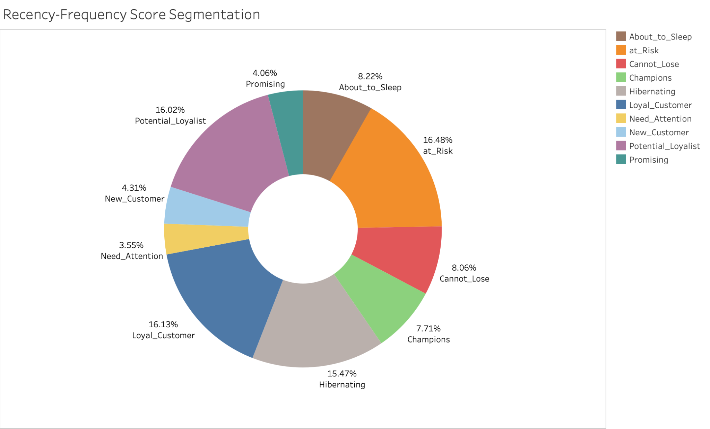

* 1. **Future Customer Behavior Prediction**

In order to analyze different aspects of our customers, for different approaches we had built different models. In order to predict whether our customers would spend the max amount of money on wine products we have set our dependent variable as the max spend on wine. The test accuracy provides us a percentage of chance that our prediction is correct or not. For example, for our random forest classification, it provides us a test accuracy of 0.8223 which means if we need to predict 1000 customers, and find out whether they are more likely to spend the max on wine, we will be able to 822 customers correctly. This also applies to other models too. Since our random forest model has the highest test accuracy and AUC score, we would like to use this method in prediction of our future return customers whether they would purchase wine at their next visit.

* 1. **Examining Relationship between Independent Variable and Dependent Variable**

By analyzing the output of these models, we have identified important customer behaviors, background, and characteristics that would play an important role in predicting our dependent variable. By looking at the split of the pruned tree, we have seen that decisions could be changed based on the income level, education background and number of teens at home. For the regression tree, each of these variables have a low p-value. For example, the naive bayes model’s summary clearly shows there are differences between the mean income of customers who are likely to spend max on wine or not. Other than that, we could conclude from the Random Forest Report that the Mean Decrease Gini of Income, Education, Teenhome is also high. Therefore, after interpreting the model’s output, we had found out that Income, Education, Teenhome, NumWebVisitsMonth would affect whether the customer would decide to spend the max on wine the most.

* + 1. Random Forest
       - Customers with annual Income less than $30359.5 are less likely to spent more on wine.
       - For Customers with annual income greater than $30359.5:
         1. Those have teenagers at home are more likely to buy wine
         2. Those don’t have teenagers at home, with education level of basic, master or PhD are more likely to buy wine
       - For Customers with annual income greater than $30359.5, no teenagers at home, education level of 2n cycle and college:
         1. Those annual income less than $47869.5 are less likely to buy wine
         2. Those annual income greater than $47869.5 are more likely to buy wine

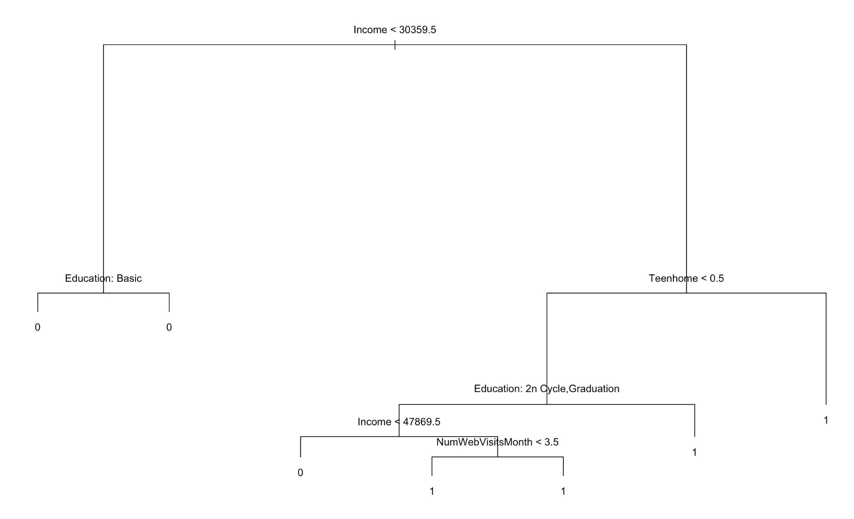

* + 1. Naive Bayes
       - Among all the customers whose education background is 2n cycle, they are more likely to spend the max on wine, by comparing 0.15 and 0.57.
       - Probability of education background is basic and the maximum spend on wine is 0 because in our train dataset, all the customers who have basic education will not spend max on wine.
       - Customers who are likely to spend max on wine are those customers who have a mean income of $53,736 compared to a mean income of $39,641.
       - The mean number of deals purchased for customers who are more likely to spend max on wine is higher than those not.
       - There is a clear difference between the amount of store purchase for customers who spent max on wine or not, which is making sense because based on common knowledge people tend to purchase wine in store more than online. 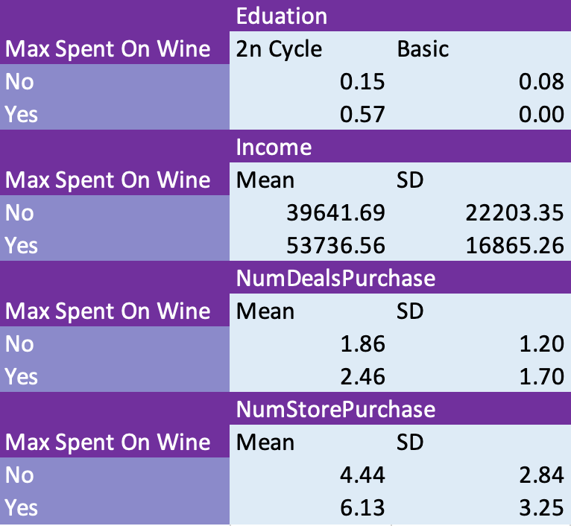
    2. Logistic Regression
       - A one-dollar increase in income increases the odds of spending most on wine by a factor of 1.000047
       - one increase in the number of teenagers at home increases the odds of spending most on wine by a factor of 4.8694
       - A one day increase in the number of days since last purchase decreases the odds of spending most on wine by a factor of 0.9955
       - A one unit increase in the number of purchases with discount increases the odds of spending most on wine by a factor of 1.1316
       - A one unit increase in number of website visits last month increases the odds of spending most on wine by a factor of 1.2378
       - The odds of customers who accepted offers in the last campaign spending the most in wine are 0.9342 times the odds of customers who do not accepted offers in the last campaign spending the most on wine

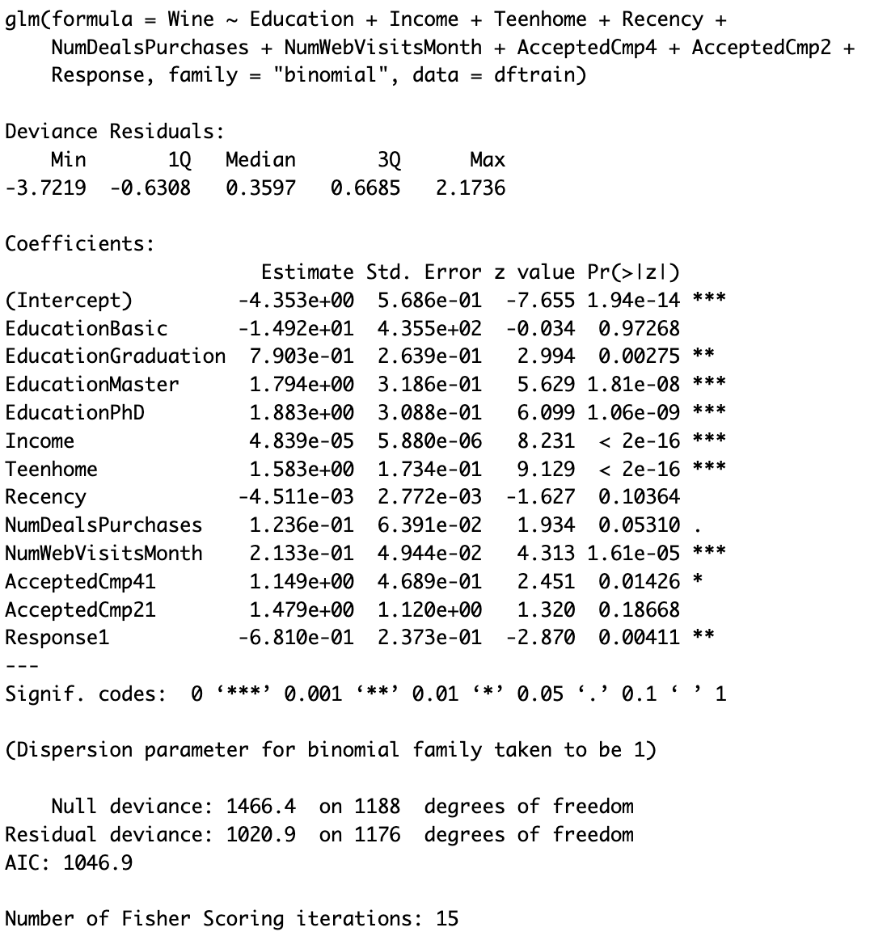

* + 1. Promoting New Business Strategies by Using Association Rules

We had selected the best two rules for our clients to act on right now, the right-hand side of the first rule is {max spent = wine}. By inspecting the rules we can gather information on what kind of customer could spend the max amount on wine from the left-hand side. Therefore we had provided our client with the following actions, to promote new arrival and selected wines for customers who have median income, do not buy fish products, and do not complain. We had also selected another right-hand side as deal_prefer=yes, we would want to see what kind of customers who prefer deals. And we had come up with a recommendation for our clients which is: Provide digital coupons that can be used on online sale platforms for customers who would buy gold products, spend the max on wine, prefer the purchase method as web, visit our client’s website more often.

* + 1. Performance Characteristics

We evaluated the performance of our models based on the accuracy score and ROC curve for these four predictive models. They are summarized as follows:

|  | Regression tree | Random forest | Naive Bayes | Logistic Regression |
| --- | --- | --- | --- | --- |
| Accuracy | 0.7893 | 0.8274 | 0.7513 | 0.8071 |
| AUC | 0.739 | 0.777 | 0.736 | 0.748 |

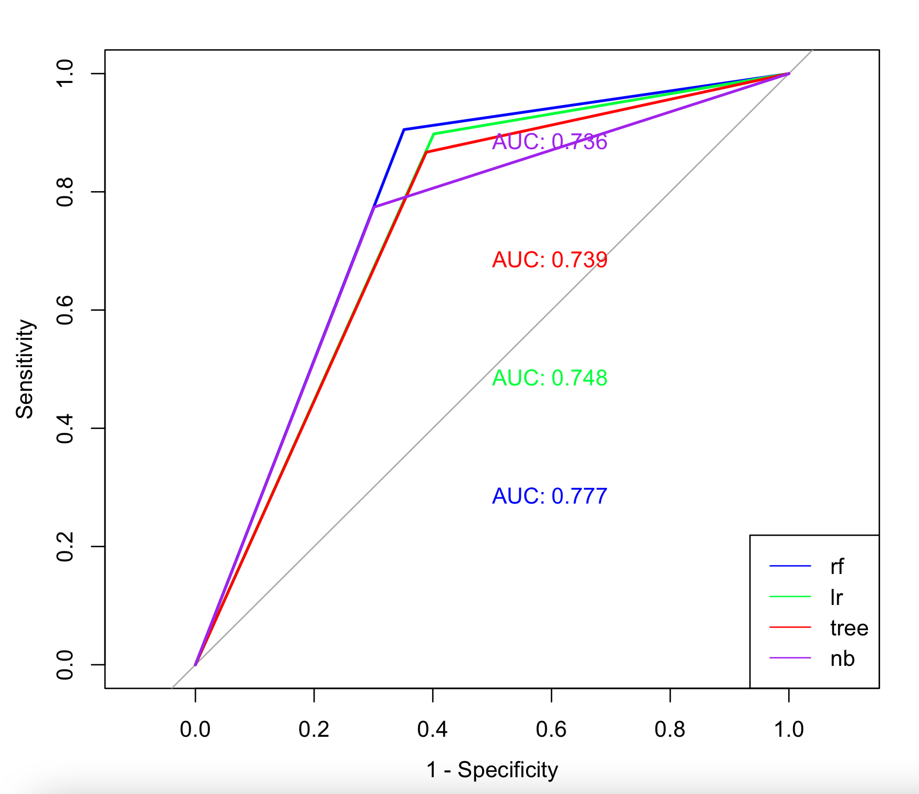

The regression tree is pruned to remove parts of trees that are not useful for prediction. The tree finally ends with 7 final nodes, which have the lowest deviance. For logistic regression, we used a backward stepwise feature selection method to remove unnecessary independent variables, and the model finally ends with variables including Education, Income, Teenhome, Recency, NumDealsPurchases, NumWebVisitsMonth, AcceptedCmp, and Response. Based on the p-value, most of the variables are statistically significant, except recency, NumDealsPurchases, and AcceptedCmp2. The random forest not only provides the prediction outcomes but also the feature importance for each variable. It shows that Income is the most important variable for the prediction.

According to the ROC curve, the ROC curve for these models is very close, but the curve for the random forest is further out the most compared to others. Overall, since the random forest has high accuracy, it is a powerful model to predict whether or not a customer will spend the most on wine.

For association rules, we discovered what will associate with the max spending on wine and what will associate with preferring deals. We set the minimum support threshold to 0.1 and the minimum confidence to 0.7. {Income=median, FishProducts=no, Complain=no}is associated with {max_spent=Wines}, with a support threshold of 0.1033, a confidence of 0.9582, and a lift ratio of 1.3969. For the rule {Income=median, GoldProds=yes, max_spent=Wines, purchase_media=Web, web_visits=more-likely} => {deals=prefer}, the support threshold is 0.1097, the confidence is 0.8934, and the lift ratio is 1.6334. Both rules have lift ratios that are greater than 1, which indicates that the antecedent set and the consequent set appear more often together than expected. Since our dataset has many rows and columns, the low support can still provide informative rules.

1. ***Future Improvement and Business Model Application***

We will use Random Forest Classification method to predict potential targeted customer for different kinds of promotion. However, we need to improve on our models since our random forest provides us FDR = 0.147 and FOR = 0.263. Since we have a solid business plan and model, there we can apply our system of analysis to different customer aspects. Our dependent variable is subject to change in the future for more opportunities and different categories, such as which platform do our customers most prefer, who are our customers that would like to participate in the campaign, etc.

1. ***Conclusion***

Customer analysis is a crucial aspect of any successful business strategy. Without understanding customer behavior, preferences, and needs, it is impossible to create a successful marketing and promotional strategy that leads to a steady flow of satisfied and happy customers. The process of customer analysis involves a thorough examination of past and future customer data to identify key customer groups, behaviors, and preferences. We use three steps to understand our customers, an analysis of past customers, a forecast and predict of the future, and find potential marketing strategies. For understanding our customers we transformed customer behavior using RFM and later used different machine learning methods to make predictions. After RFM, we split customers with different levels of loyalty, which means we had to design different business strategies. For forecast and predict of the future, we use Regression Tree method, Naive Bayes method, and logistics regression, and all method have good performance in accuracy of prediction. The final step to develop target marketing strategies that could improve KPI and ROI and directly impact business performance is we used the method of association rule to build different business strategies that should be efficient. By taking the time to understand customers, businesses can improve their bottom line and build long-lasting relationships with their customers.

1. ***Appendix***
   1. **Data Dictionary**:

| Column Name | Type | Unit | Column Description |
| --- | --- | --- | --- |
| ID | int | NaN | Customer's unique identifier |
| Year_Birth | int | NaN | Customer's birth year |
| Education | chr | NaN | Customer's education level |
| Marital_Status | chr | NaN | Customer's marital status |
| Income | int | USD | Customer's yearly household income |
| Kidhome | int | NaN | Number of children in customer's household |
| Teenhome | int | NaN | Number of teenagers in customer's household |
| Dt_Customer | chr | NaN | Date of customer's enrollment with the company |
| Recency | int | NaN | Number of days since customer's last purchase |
| Complain | int | NaN | 1 if the customer complained in the last 2 years, 0 otherwise |
| MntWines | int | USD | Amount spent on wine in last 2 years |
| MntFruits | int | USD | Amount spent on fruits in last 2 years |
| MntMeatProducts | int | USD | Amount spent on meat in last 2 years |
| MntFishProducts | int | USD | Amount spent on fish in last 2 years |
| MntSweetProducts | int | USD | Amount spent on sweets in last 2 years |
| MntGoldProds | int | USD | Amount spent on gold in last 2 years |
| NumDealsPurchases | int | NaN | Number of purchases made with a discount |
| AcceptedCmp1 | int | NaN | 1 if customer accepted the offer in the 1st campaign, 0 otherwise |
| AcceptedCmp2 | int | NaN | 1 if customer accepted the offer in the 2nd campaign, 0 otherwise |
| AcceptedCmp3 | int | NaN | 1 if customer accepted the offer in the 3rd campaign, 0 otherwise |
| AcceptedCmp4 | int | NaN | 1 if customer accepted the offer in the 4th campaign, 0 otherwise |
| AcceptedCmp5 | int | NaN | 1 if customer accepted the offer in the 5th campaign, 0 otherwise |
| Response | int | NaN | 1 if customer accepted the offer in the last campaign, 0 otherwise |
| NumWebPurchases | int | NaN | Number of purchases made through the company’s website |
| NumCatalogPurchases | int | NaN | Number of purchases made using a catalogue |
| NumStorePurchases | int | NaN | Number of purchases made directly in stores |
| NumWebVisitsMonth | int | NaN | Number of visits to company’s website in the last month |
| Z_CostContact | int | NaN | Null |
| Z_Revenue | int | NaN | Null |